Delta has a requirement to ship a specific amount of ‘touch up paint’ with each order. The qty of touch up paint needed is based on the total linear feet per finish.

On a customer order, there can be various types of finishes on the line items as shown in the screenshot below. This is CO102289 in Production.

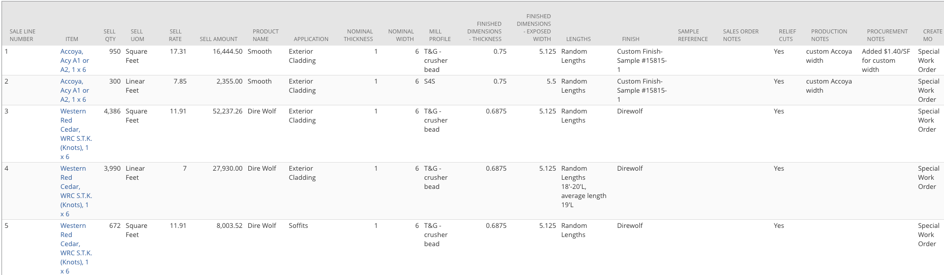

We will want to have a scheduled script that runs nightly to determine the total amount of touch up paint required for each finish per customer order.

If the Finish field on the customer order line is NULL or contains the value of Unfinished, then that line can be ignored from this customization.

There will be a new item created titled Touch Up Paint (already created in sandbox. Internal ID 933).

There will be a custom table that will hold the details of how to determine amount of touch up paint required based on linear feet (see details below).

There will be a checkbox at the header level of the order titled ‘Touch Up Processed’.

The guidelines for determining the amount of finish is as follows:

1-1499 linear feet = 1 qt

1500-2499 = 2 qt

2500-3999 = 1 gallon

4000 - 8000 = 2 gallon

8001 - 11000 = 3 gallon

11001 - 14000 = 4 gallons

Over 14000 = 5 gallons

When the script runs it will:

* The script will look for orders created that day.
* Group lines on a customer order by finish, so in the screenshot above there would be two groupings. One for Custom Finish- Sample #15815-1 and one for Direwolf.
* Add the total Qty on the lines by Finish. Example: In the order above, Custom Finish-Sample #15815-1 would have a total of 2,524.4 linear feet and Direwolf would have a total of 16,323.2 linear feet.
* A new line item would be created on the customer order for each Finish. The item used would be the new Touch Up Paint item. The qty for these new lines would be 1 and amount would be 0. We would populate the details in the Description field on the line. Example: In the screenshot above two new lines would be added.
  + Item: Touch Up Paint, Qty: 1, Amount: $0.00, Description: Custom Finish- Sample #15815-1, 2,524.4 Linear Feet, 1 Gallon and applicator bottle. (calculation will be used to determine the amount of touch up paint needed).
  + Item: Touch Up Paint, Qty: 1, Amount: $0.00, Description: Direwolf, 16,323.2 linear feet, 5 Gallons.
* After new lines have been added then check the Touch Up Processed box at the header of the customer order.

**CHANGES**

Delta Millworks would like to modify how the current Touch Up Paint solution is working. Please see below:

* They would like to change the name of the current Finishes field and have it read as Custom Finish.
* They would like to create a new List field at the sales order line level titled Finish.
* The list would contain the values from column C in this .xls sheet. The list should also include the value CUSTOM. 
* The logic of the Touch Up Paint script will now look to group by this new List field instead of the existing Finish field.
* The Sales Order Notes and Description fields on the Touch Up Paint lines that get added to the order will now need to include the Finish value from the new list field as well as any value that might be entered in the Custom Finishes field.
* All calculations remain the same, meaning you still use the Qty field to determine total number of quarts/gallons.